Project Design Phase
Solution Architecture
Date | 14 July 2026
Team ID | SWTID-2026-7493
Project Name | Book Store
Maximum Marks | 4 Marks
Solution Architecture: Book Store Application
Solution architecture bridges the gap between the business problems identified during ideation and the technology solution that will solve them for the book store application. It aims to:
- Find the best technology solution for discovery, pricing transparency and delivery-visibility problems faced by readers.
- Describe the structure, characteristics and behaviour of the application for all project stakeholders.
- Define features, development phases and solution requirements.
- Provide specifications according to which the solution is built, managed and delivered.
Architecture Diagram
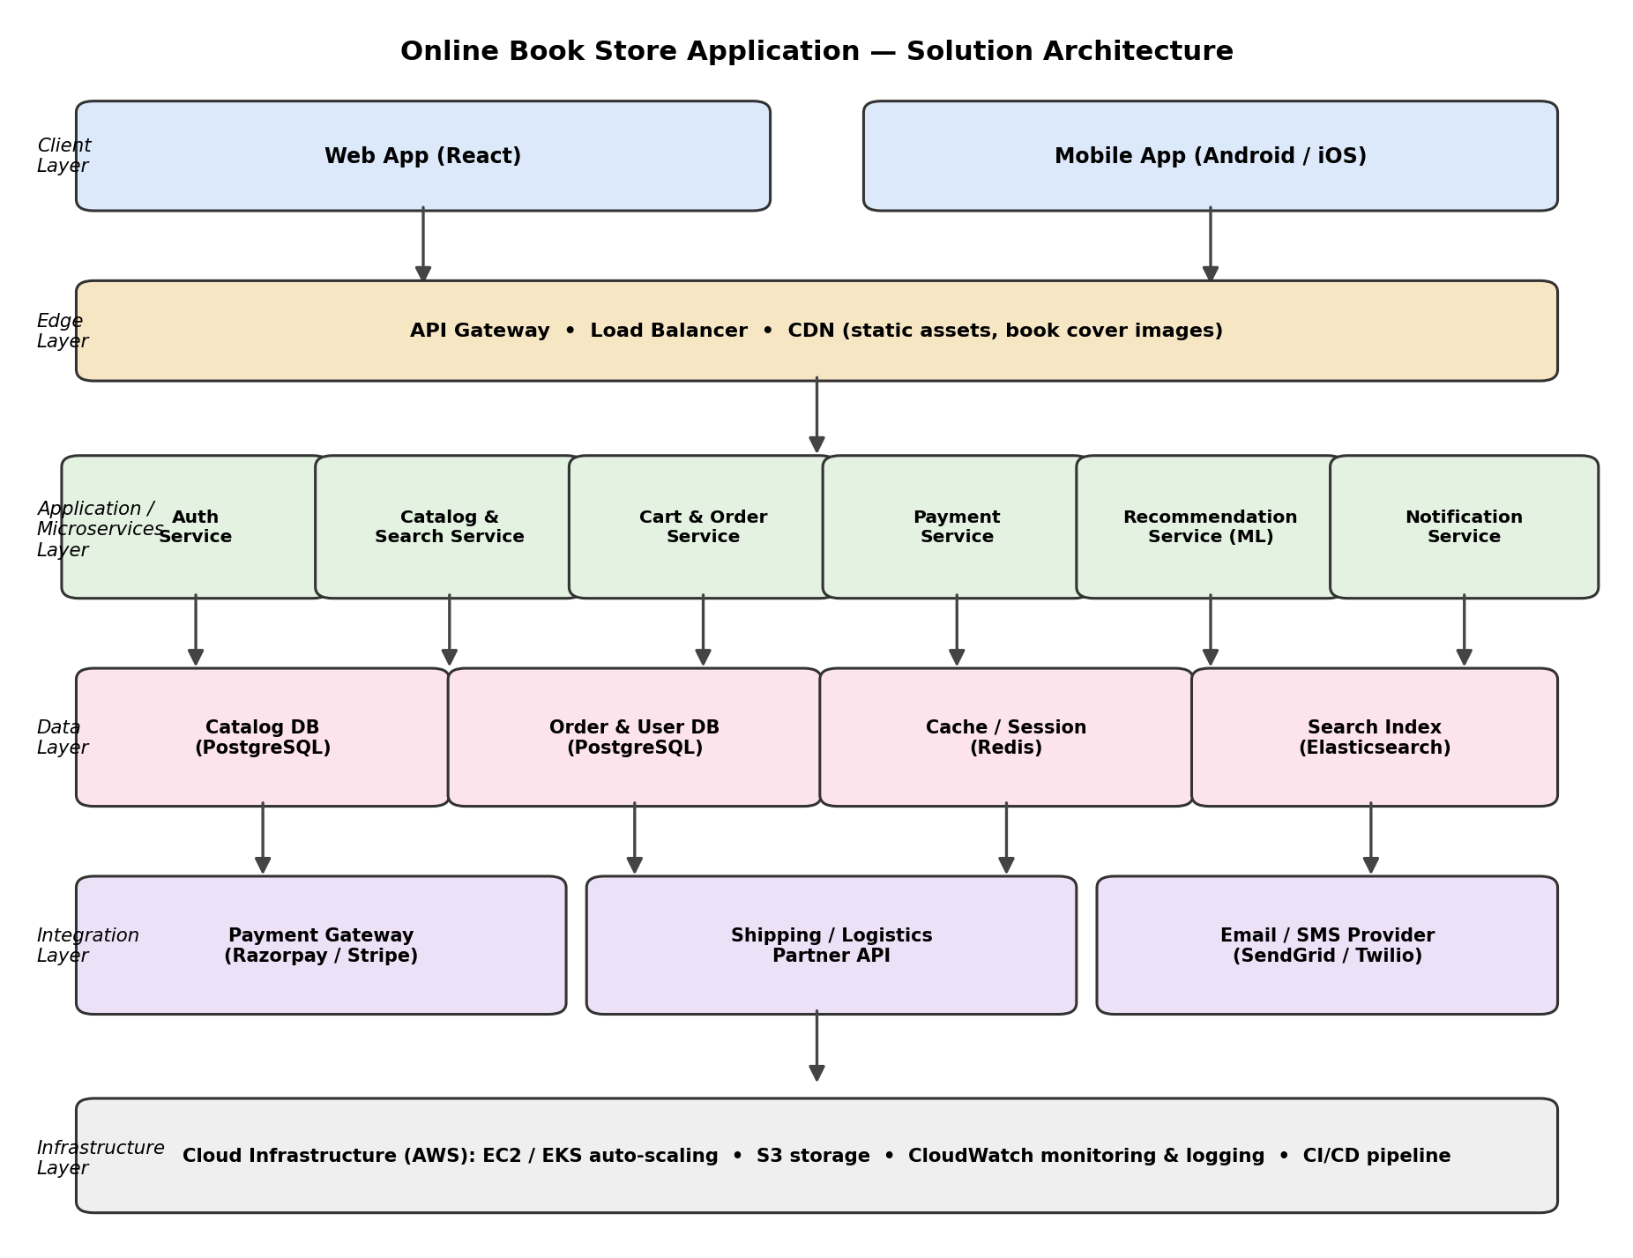
Figure 1: Layered solution architecture of the Online Book Store Application
Component Description
Layer | Components / Technology | Purpose
Client Layer | Web App (React), Mobile App (Android/iOS) | Provides book browsing, search, cart, checkout and order-tracking screens to the customer.
Edge Layer | API Gateway, Load Balancer, CDN | Routes requests to the correct microservice, enforces rate limiting and auth-token checks, and serves static assets (book covers, banners) from the CDN for fast page loads.
Application / Microservices Layer | Auth, Catalog & Search, Cart & Order, Payment, Recommendation (ML), Notification services | Each service owns a single responsibility so it can be developed, deployed and scaled independently.
Data Layer | Catalog DB & Order/User DB (PostgreSQL), Cache/Session (Redis), Search Index (Elasticsearch) | Stores book catalogue, orders and user data; Redis speeds up sessions and recommendation lookups; Elasticsearch powers fast, relevant search.
Integration Layer | Payment Gateway (Razorpay/Stripe), Shipping/Logistics Partner API, Email/SMS Provider (SendGrid/Twilio) | Connects the platform to third-party services needed for payments, delivery tracking and customer notifications.
Infrastructure Layer | AWS (EC2/EKS auto-scaling, S3, CloudWatch, CI/CD) | Hosts and monitors the platform, scales services automatically with demand, and automates build/deploy pipelines.
Key Data Flow
- Customer requests reach the API Gateway via the web or mobile client, through the CDN for static assets.
- The gateway authenticates the request with the Auth Service, then routes it to the relevant microservice (Catalog, Cart & Order, Payment, Recommendation, or Notification).
- Microservices read/write to their own data stores; Redis caches frequent catalogue and session lookups; Elasticsearch serves search queries.
- Order and payment events trigger calls to external Payment Gateway, Shipping Partner API and Notification provider.
- All services run on auto-scaling cloud infrastructure, with centralised monitoring and an automated CI/CD pipeline for releases.

